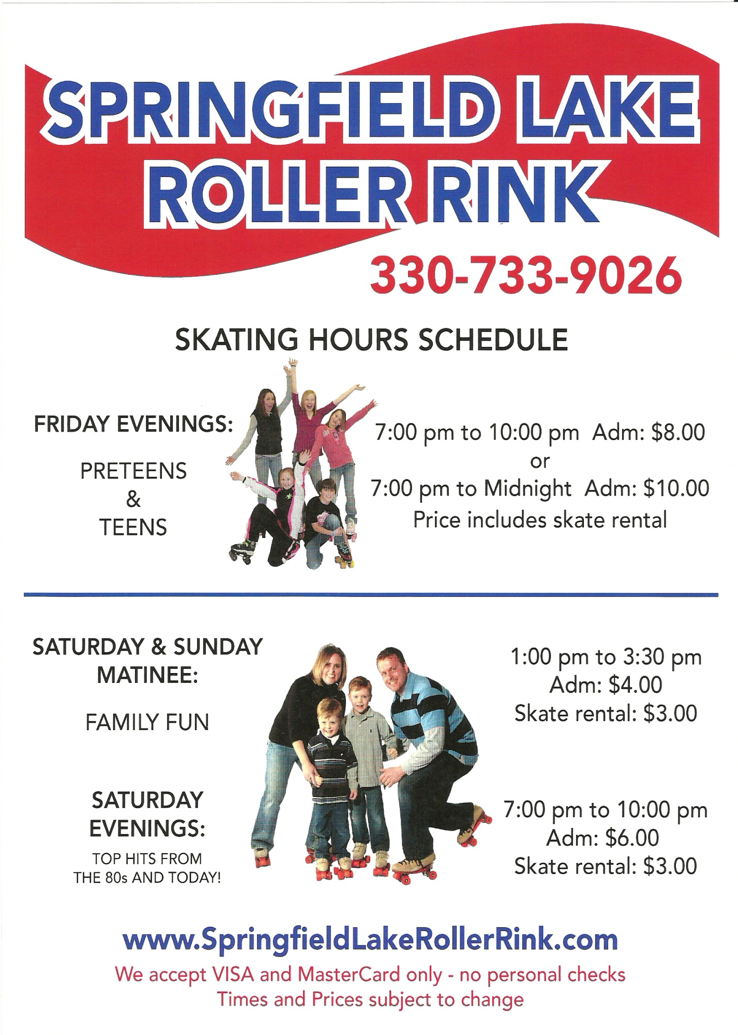

7:00 pm to 11:00 pm   
Adm: $10.00  
Skate Rental: Included

1:00 pm to 3:30 pm   
Adm: $5.00  
Skate Rental: $3.00

7:00 pm to 10:00 pm   
Adm: $6.00  
Skate Rental: $3.00